Chapter 19, Solution 97

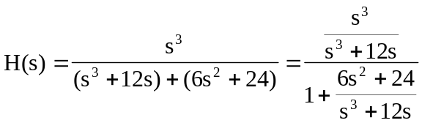

Hence,
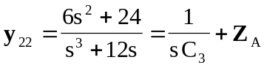 (1)

where 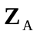 is shown in the figure below.

Z_{A}

y₂₂

C₁
L₂
C₃

We now obtain 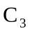 and using partial fraction expansion.
Let 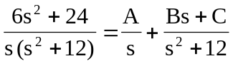
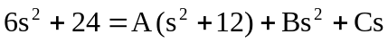

Equating coefficients :
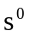: 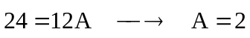
: 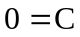
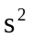: 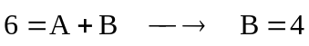

Thus,
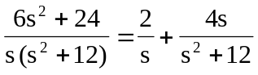 (2)

Comparing (1) and (2),
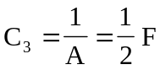

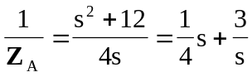 (3)

But 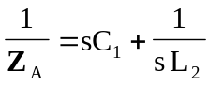 (4)

Comparing (3) and (4),
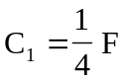 and 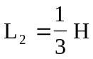

Therefore,
 